**Practical 2**

0bjective:

To learn the usage of excel compute measures of central tendency (mean ,median ,mode).

Problem Statement:

For the following set of data representing the age in years of the residents of a given building compute mean , median , mode of the ungrouped data

Also,

* Construct a frequency distribution with interval of 15-19,20-24,25-29,30-34,35-39…...
* Bcompute the mean, median, and mode of the grouped data.

Theory:

In this practical we have used sum, average, median, mode function to calculate the data using =sum () function adds values . you can add it individually or you can select range. Eg =sum (A2:A10)

The =average () function is a premade function In excel. It helps to calculate the average from the selected range.eg =average (A2:

Print the output

**Practical 3**

0bjective:

To learn the usage of excel Formula functions.

Problem Statement:

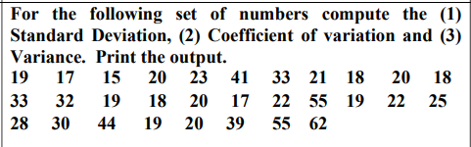

Theory:

In this practical we have used average,stdev.s,var.s these are built in function In excel.

Steps:

1. Open MS excel
2. Select the range where you want to apply formula
3. Calculate mean by using =Average function
4. Then calculate to calculate standard deviation use =stdev.s function
5. Next step is to calculate variance for that you can use =var.s function
6. Next,to calculate coefficient of variance divide standard deviation to mean and mutiplly It by 100
7. Save the file

Output:

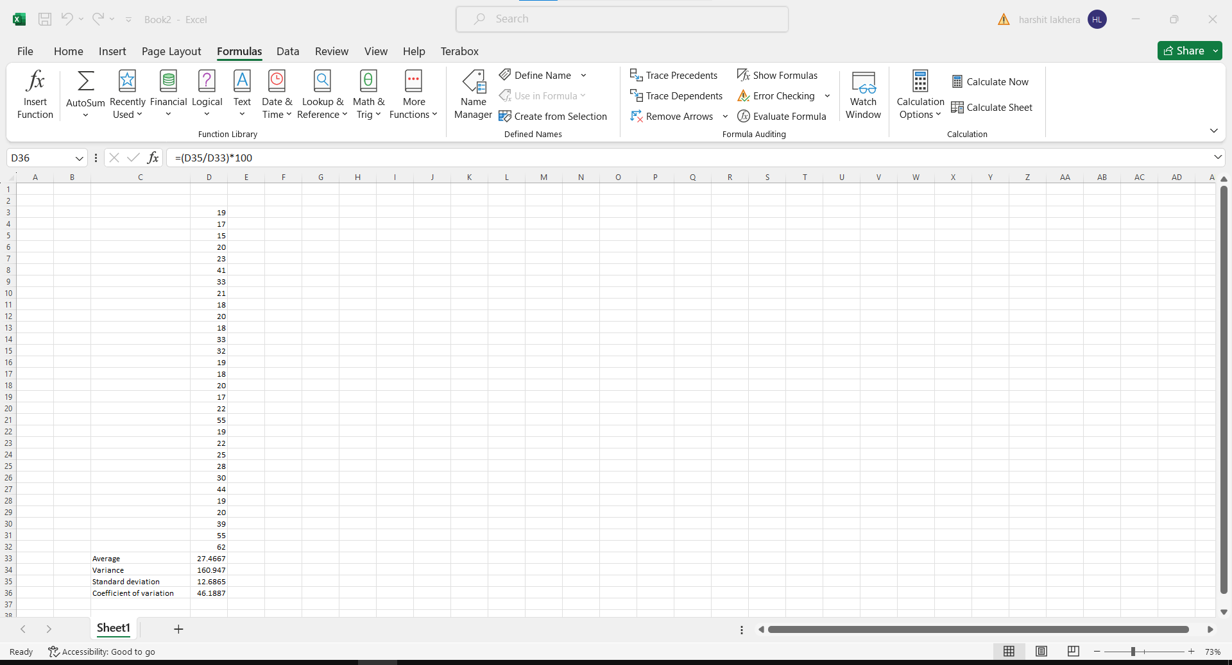**Practical 6**

0bjective:

To learn the usage of excel formulas.

Problem Statement:

For the following Table calculate

* The average number of students in the entire distribution.
* The standard deviation of the distribution.
* The correlation coefficient between the number of schools and the number of candidates.
* The regression equation between number of students and number of candidates.

Theory:

In this practical we have used sum, average, stdev.s,linest

output

**Practical 7**

0bjective:

To learn the usage of excel pivot table.

Problem Statement:

Using Pivot table, determine

* The number of Nationality per Location
* The number of Department / location / clients
* The number of client / location / nationalities

Theory:

Pivot tables are among the most useful and powerful features in Excel. We use them in summarizing the data stored in a table. They organize and rearrange statistics (or "pivot") to draw attention to the valuable facts.

Steps:

1. Open MS excel.
2. Click on insert tab and then goto charts section.
3. Then select pivot table and select range of the data .
4. And select new worksheet.
5. For number of Nationality per Location drag loaction and nationality to rows section
6. And nationality to value section.
7. For the number of Department / location / clients department ,locationand nationality
8. to rows and value section.
9. For the number of client / location / nationalities you need to value field setting and
10. choose count option.
11. Save MS excel file.

Output:

